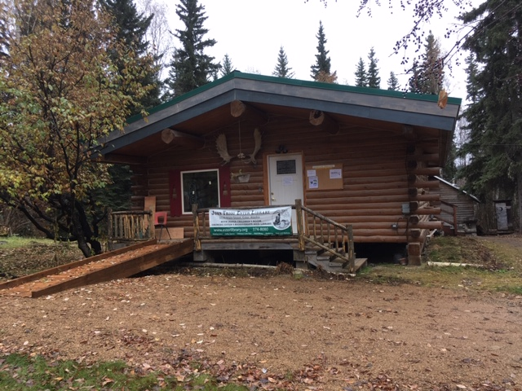

FY 2018 ANNUAL REPORT

Of the John Trigg Ester Library

Message from the President

October 22, 2018

Welcome! It’s been another exciting year! We started the new fiscal year with the annual retreat, where the Board of Directors outlined our goals and objectives for the upcoming year. The overall goal: continue with the Clausen Cabin renovation and put books on the shelves!

Since the majority of the remaining work on the Clausen Cabin was exterior work (refurbish roof and under floor insulation), we focused our wintertime efforts around a new children’s reading program, called “Kids Read” and putting more books on the shelves. Altogether, 10,030 books have been entered into our online catalog. Additionally, we held 4 Kids Read events.

Summer and fall saw renovation of the decades-old roof. Weather and time had taken their toll, and portions of the old roof were rotten and leaking. Thanks to a GVEA GoodCents grant of $5000, the entire roof was renovated and insulation added to bring the roof up to R60. Finally, in the gazebo, the last two stained glass windows were installed with their protective plexiglass shields, a picnic table and a memorial plaque honoring Ida Lane Clausen were added, with the re-dedication to be held immediately following the Annual meeting.

Aside from hard work, we hosted Galen Garwood, the son of Ida Lane Clausen, for his book signing event, held 2 fund raisers to generate the necessary income for operating the library and was the recipient of Stantec Engineering’s “Stantec in the Community” assistance to local non-profits, where they spent several hours cleaning and clearing debris and brush, and then built a sign for the Passive House space.

The current Board of Directors continues to be the driving force behind the metamorphosis of a few buildings and structures into a true library/community center/campus that it has become – thank you for your selfless service, and countless hours of backbreaking and tedious work!

Sincerely,

Syrilyn Tong, President
2016-2018

Facilities Committee

The committee’s main work centered around the renovation of the roof of the Clausen Cabin. Headed by Gary Pohl, the following were accomplished:

- Landscaping spruce up, brush clearing, trash and debris hauled away.
- Door to the brown building lower hinge repaired so that it fully shuts.
- Clean out and organization of the brown building.
- Clean out and organization of the white building.
- Construction of a new stoop for the white building.
- Garden Beds: Two units have been assembled and old root wad beds scraped off by Tandem Enterprises.

The old roof

- Clausen Cabin Roof Replacement:
- Existing aluminum roofing has been removed and salvaged.
- Roof framing system has been increased in thickness with new framed trusses that were prefabricated on the back deck.
- Insulation dams have been placed and new blown-in cellulose insulation has been added on top of the existing 8 inch batts (yes, that’s all there was!) to bring the roof R-value up to at least R-60 or higher.
- Existing flues were removed and the vapor barrier patched, eliminating two sources of roof leaks, infiltration and heat loss.
- Existing CPVC plumbing vent has been replaced with ABS and sealed tight.
- New plywood sheathing has been installed and covered with self-adhering ice dam protection (Ice and Water Shield) for the bottom 6 feet, and 30# felt underlayment.
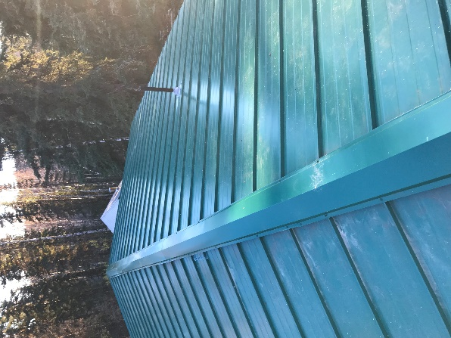

The new roof
- Stantec in the Community: Volunteers from Stantec Engineering picked JTEL as their non-profit to help for the day, and helped haul off two large pick-up loads of trash from the Clausen Cabin, built a sign stand for the Passive House project, and cleaned up the gazebo grounds.
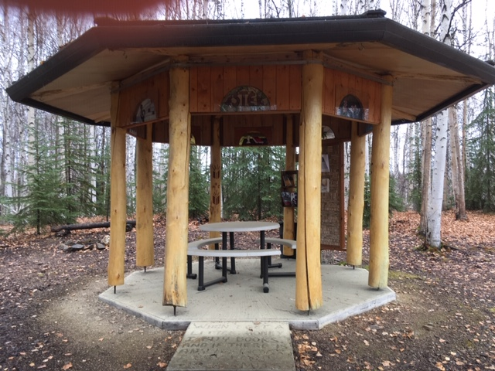

- The gazebo’s last 2 windows were installed, and a picnic table and memorial plaque were added to finish the area.

Collections Committee

Headed by Mindy Gallagher.

Cataloging became a regularly scheduled activity this year, and the cataloging group met almost every week for at least 2 hours each week. At any one session, we had 2 – 5 volunteers cataloging and shelving books. An additional 1700 titles were added to our online system with LibraryThing and set up with card pockets, ready to be checked out.

Sherri Schleiter went through books in the red house and culled some books which were in poor condition. Twenty books were removed from the catalog and identified to be sold. Total number of books cataloged is now 10,030.

The focus this year was on Young Readers/Children, Young Adult/Teen, Alaskana, Adult Fiction, and an assortment of nonfiction titles in History, Memoirs, Science and Natural History, Philosophy and Spirituality, Women’s Studies, Travel, and Arts. Once the latest donation of children’s books is cataloged, we plan to start on the books from the Four Winds collection, which Monique Musick has sorted through, selecting 4 boxes for our initial efforts.

Among the books cataloged this year were the ones donated from the Women’s Center at UAF, and some of the books donated by Chris Guinn a couple of years ago. Other donations were received from Ray Hadley’s estate, Ritchie Musick, Ruth Rutherford, Jessica Westfall (RSMS teacher), Cathy and Larry Roberts, Sherri Scheliter, and the Helfferich family, as well as other small donations.

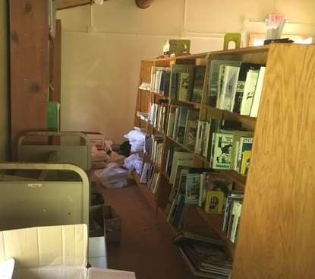

Thank you to the collections volunteers this year: Kay Sisson, Suzann Suzawith, Kimber Sprague, Janet Thompson, Karyn Holder, Ruth Rutherford, Sherri Schleiter, Deirdre Helfferich, Monique Musick, Eli Sonafrank, and Ginny and Mindy Gallagher.
Grants Committee

Headed by Gary Pohl, the grants committee was hampered by the fiscal crisis on the State-wide level. As such, proposals were submitted to the State for “interest”, as no monies were awarded. However, the big grant of note was GVEA’s Good¢ents grant written entirely by Gary. This $5000 grant went towards the roof renovation, and because of that, the dollars-and-cents cost to JTEL was only $3,663. Additionally, Gary was able to acquire the Lowe’s Hardware non-profit rate on building materials and supplies, which further reduced the cost.

Policy Update Committee

Headed by Carrie Correia, the policy update Committee continued to look at the remainder of JTEL’s previous policies and revise them so that they were current and more streamlined. She, along with Syrilyn Tong, also recommended changes to the by-laws (see section on “Proposed By-Laws Changes”).

- Membership Policy – revised and updated
- Collections Policy – revised and updated
- Building Reservations and Use – created in order to allow patrons to reserve areas of JTEL
- Programs and Activities Policy – updated and streamlined
- Document Retention Policy – created so as to define how long certain documents are kept
- Finance Policy – created, but not finished yet

Volunteers & Memberships

Headed by Syrilyn Tong. Volunteers are the heart of any organization, and as such the development and use of them is invaluable. Our volunteer base now has 54 people, while we now boast 150 members.

Website Renovation & Marketing

Headed by Monique Musick. Monique continued to update and change our current website, and has become the de-facto photographer and marketing guru, using her invaluable skills in flyer production and editing to really showcase the events sponsored by the library.

Historian Committee

Headed by Sherri Schleiter. Thus far, a complete set of the Ester Republic has been collected and bound together for reference use in the library. A couple of photo albums have been created and the committee requests assistance identifying those in the photos. A meeting is planned for November of 2018 to start this process. Some electronic sources have been useful regarding the history of the Ester library. In addition, a scrapbook has been started that highlights the history of the JTEL library and the Clausen Cabin.

Finances
Current balances, as of 9-30-18

Passive House Savings Balance: $14,410.46

Regular Savings balance: $18,713.70

Regular Checking balance: $ 1,343.18

Change fund balance: $ 50.00

Endowment fund: $ 5,558.86

Current Restricted Funds, 9-30-18

Ruth Jasper Children’s Fund $ 1,720.00

Gazebo Fund $ 110.54

FY17 vs. FY18 Profit and Loss Statement
Income
 | Direct Public Support
 |  | Individ/Business Contrib. | $3,120.94 | 2,579.08
 |  | Li-Berry Music Festival | $3,972.11 | 2,451.82
 |  | Tape and Tarp Ball | $2,067.45 | 2,672.35
 | Total Direct Public Support |  | $ 9,160.50 | 7,703.25
 | Foundation Grants |  | $ 750.00 | 5,000.00 | GVEA Good Cents grant
 | Government Grants |  | $ 4,300.00 | 5,263.00 | FNSB Community Revenue Sharing grant
 | Interest Income |  | $ 32.62 | 31.37
 | Membership Dues |  | $ 420.00 | 1,400.00
 | Other Types of Income
 |  | Merchandise Sales | $ 418.00 | 354.00 | T shirt and Cookbook sales
 |  | Miscellaneous Revenue | $ 171.67 | 80.00
 | Total Other Types of Income |  | $ 589.67 | 434.00
Total Income |  |  | $ 15,252.79 | 19,831.62
Expenses
 | Contract Services
 |  | Accounting Fees | $ 325.00 | 340.00
 | Total Contract Services |  | $ 325.00 | 340.00
 | Facilities
 |  | Clausen Renovation | $ 3,467.87 | 8,868.55
 |  | Property Insurance | $ 936.00 | 1,110.00
 |  | Rent | $ 600.00 | 600.00
 |  | Taxes | $ 803.85 | 746.01 | Gazebo is now non-profit!
 | Total Facilities  Operations |  | $ 5,807.72 | 11,324.56
 |  |  | Fundraising Expenses
 |  |  |  |  |  |  |  | Throwdown Cookbook Expenses | $ 356.64 |  |  | 31.48
 |  |  |  |  |  |  |  | Tape and Tarp Expenses | $ 648.06 |  |  | 531.66
 |  |  |  |  |  |  |  | Li-Berry Festival Expenses | $ 651.71 |  |  | 634.76
 |  |  | Total Fundraising Expenses |  |  |  |  |  | $ 1,656.41 |  |  | 1,197.90
 |  |  | State and Borough Fees |  |  |  |  |  | $ 390.00 |  |  | 350.25
 |  |  | Books, Professional memberships |  |  |  |  |  | $ 355.94 |  |  | 356.20
 |  |  | Office Equipment |  |  |  |  |  | $ 390.00 |  |  | 30.00
 |  |  |  |  |  |  |  | Postage | $ 96.32 |  |  | 89.20
 |  |  | Printing and Copying |  |  |  |  |  | $ 114.90 |  |  | 38.48
 |  |  | Supplies |  |  |  |  |  | $ 879.59 |  |  | 1,006.79
 |  |  | Utilities
 |  |  |  |  |  |  |  | Electricity | $ 192.00 |  |  | 551.00 |  | Higher speed internet
 |  |  |  |  |  |  |  | Heating Oil | $ 2,055.02 |  |  | 1,324.00
 |  |  |  |  |  |  |  | Telephone, Telecommunications | $ 967.91 |  |  | 918.70
 |  |  | Total Utilities |  |  |  |  |  | $ 3,214.93 |  |  | 2,793.70
 |  | Total Operations |  |  |  |  |  |  | $ 6,708.09 |  |  | 5,862.52
 |  | Other Types of Expenses |  |  |  |  |  |  | $ 201.46 |  |  | 49.50
 | Total Expenses |  |  |  |  |  |  |  |  | $13,457.27 | 17,576.58
Net Income |  |  |  |  |  |  |  |  |  | $1,795.52 | 2,255.04
Programs and Events

Seedy Saturdays
This program was temporarily put on hold due to HB197’s delay in the State Legislature. This is the law that will make Alaska seed libraries exempt from prohibitive federal legislation.

In April of this year, the State Legislature did pass HB197, and next year, we’ll be back!

SuperHeroes Night Out

A major revision was needed in order to attract more patrons, thus we scrapped the “Tape and Tarp” theme and went with a SuperHeroes/Gotham City theme instead. Additionally, we moved the event to the spring, rather than fight good weather in the summer, and moved the event to the Golden Eagle.

The silent auction was by far the largest money raiser, bringing in $1283 by itself.

17 people signed up to participate in the costume contest, which was the 2nd largest money raiser. The winners were: Kayt Sunwood, Tamara Space, and Kristin Miller.

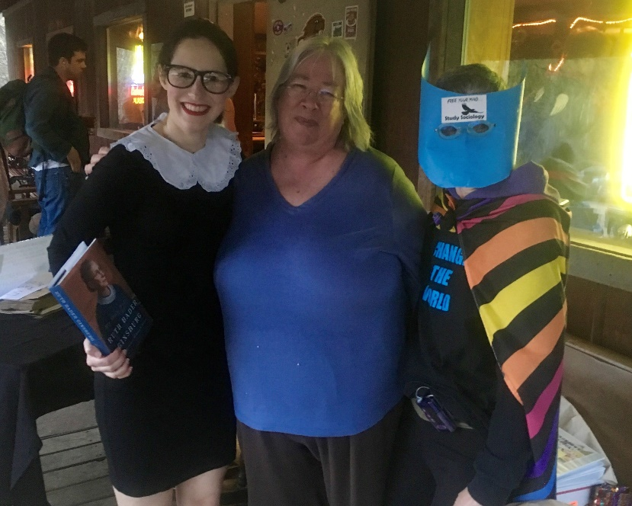

Kristin Miller, Sine Anahita and Kayt Sunwood

Auf Wiedersehen, Deirdre and Hans!

In May, our fearless leader and arguably, the one person who gave birth to the John Trigg Ester Library, Deirdre Helferrich and her husband, Hans, left Ester for Germany. A small gathering bode them farewell and she was presented with a Resolution of Appreciation for all of her years of service.
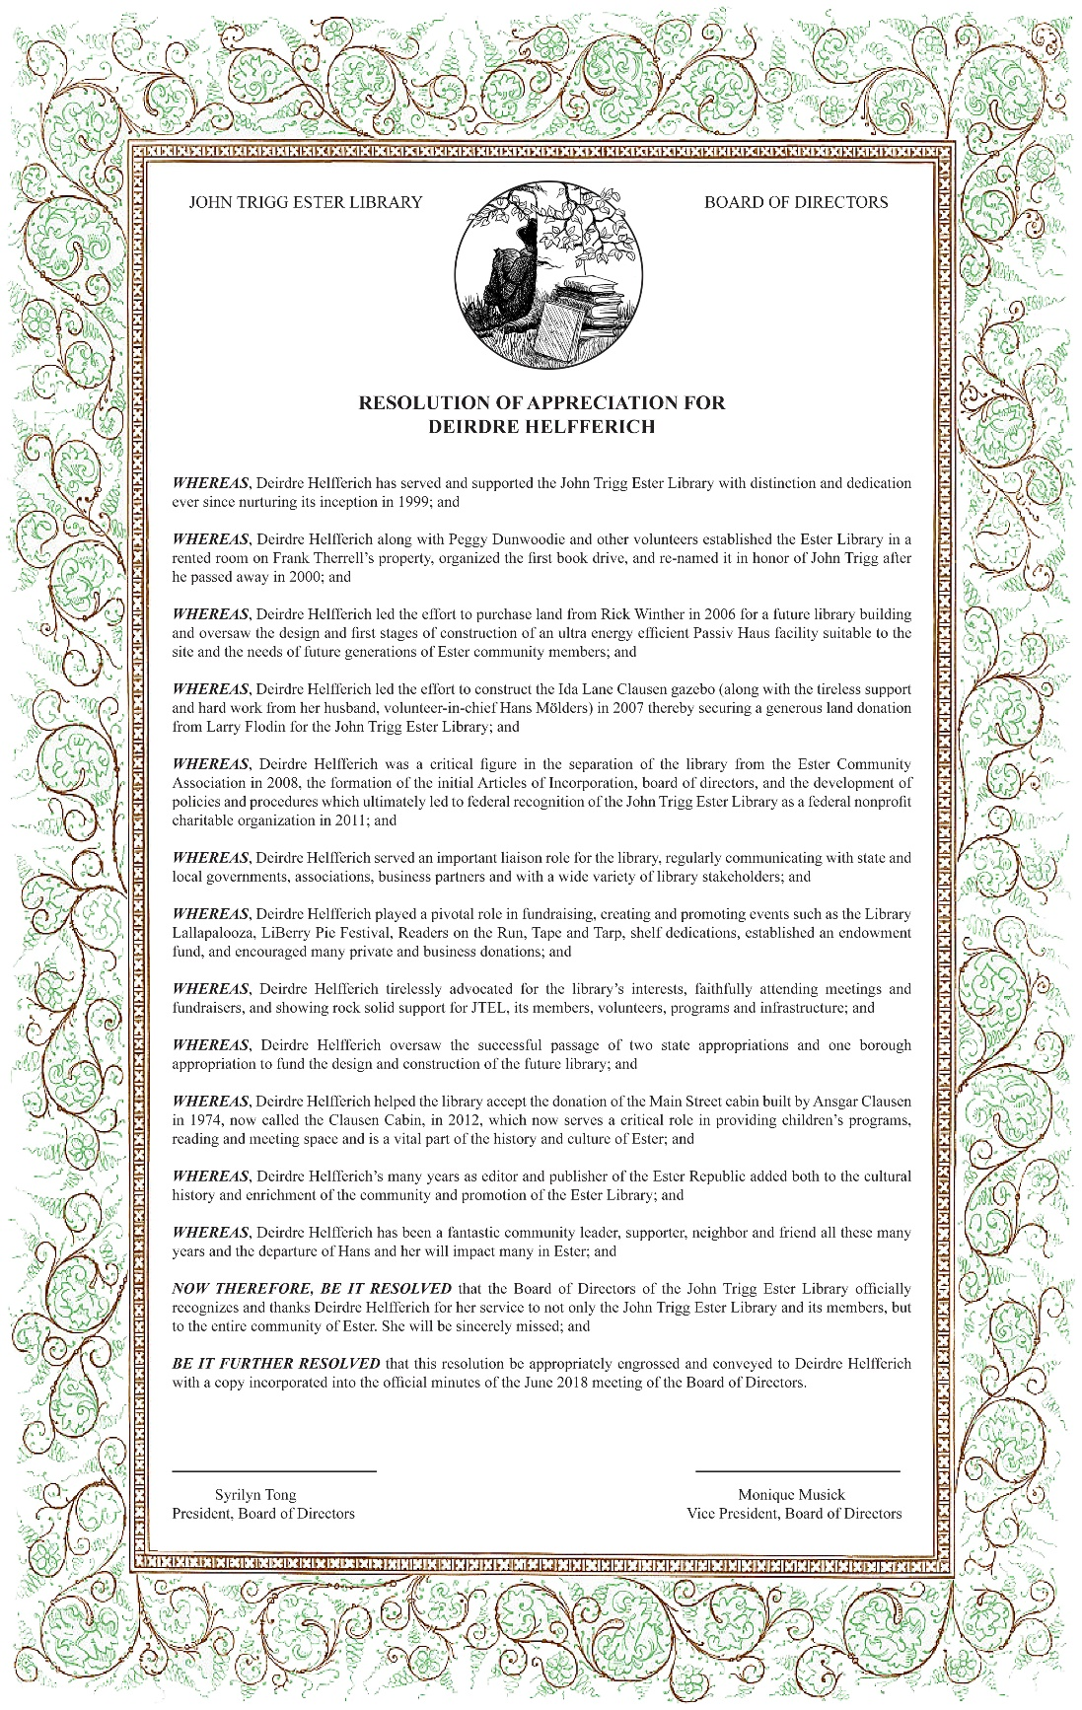

Kids Read

After receiving a $750 grant from the Alaska Community Foundation in FY2017, we purchased dozens of children’s books and began our newest program, a children’s reading program, in December, 2017.
The opening event was a reading of “Dewey the Library Cat” and “Marley Goes to School” and included meeting Vallarta, an orange long haired tabby owned by board member Sherri Schleiter. Another friend, Kolonel Mustard, a yellow lab owned by board member Gary Pohl came along to provide petting experiences to the kids in attendance.
Several Holidays were celebrated including Easter, Halloween and Groundhog Day. Dr. Seus’ birthday and Thomas the Train were also celebrated at the library. Activities included searching for Easter Eggs, decorating mandarins to look like pumpkins, Lego construction, and celebrating the Winter Olympics.

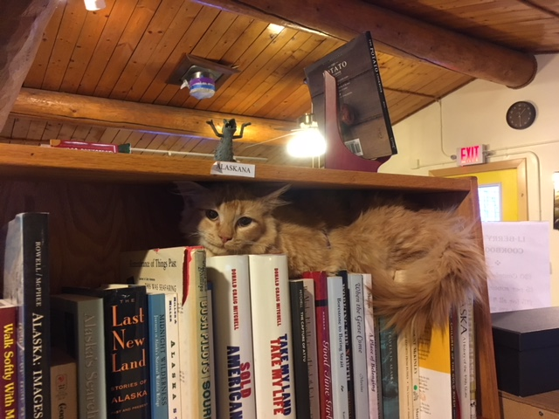

Vallarta, our library cat

Galen Garwood’s book release and signing

In July, Ida Clausen’s son, Galen Garwood, came to town to conduct a lecture and reading of his book “Sell the Monkey”, an autobiographical journey of Garwood’s sometimes difficult upbringing. The book is dedicated to Ida Clausen and her contributions to the world of music. The library hosted this event, and dozens of people were left captivated by Garwood’s reading and recitation of a Robert Service-style poem written about his Mom, then promptly bought all the books in Garwood’s possession.

LiBerry Pie and Music Extravaganza

Continuing with the changes that were implemented last year (the pie contest was held at Clausen earlier in the day, with non-winning pies and those just brought to eat available to patrons from the beginning), we held this in late September. We attracted around 100 people, all of whom became members with the $10 entry fee. Between the gate and pie sales, we netted over $3000. Liz and Sarah Furman were Grand Prize winners for the 2nd year in a row.

Stantec in the Community

We ended the year with a surprise gift from Stantec Engineering, as we were selected to be the recipient of their “Stantec in the Community” volunteer day. 8 Stantec personnel spent 4 hours removing construction debris, raking up around the gazebo, and building a new sign for the Passive House site. It was pretty cool to see the Stantec people in their black shirts in such a flurry of activity!
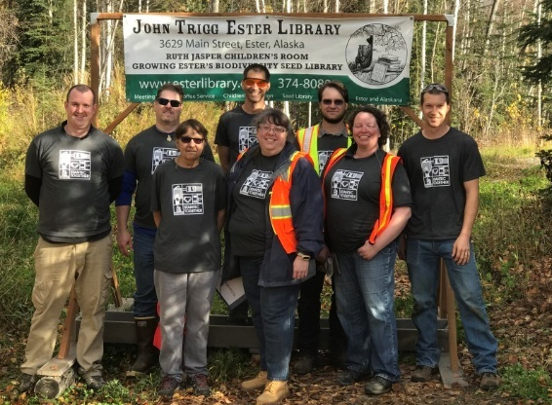

Proposed Bylaws Changes

Proposed changes are in red.

Article VI – Directors, Section 1: Designation of Officers
The officers of the corporation shall be a president, a vice president, a secretary and a treasurer. The Secretary and Treasurer position can be combined into one position if desired. There will then only be 3 officers.

Article V – Directors, Section 2 – Number of Directors
The board of directors shall number seven (7): four (4) officers and three (3) additional elected directors plus two (2) alternates. In the event that the number of officers is reduced to three (3) because the Secretary and Treasurer positions have been combined, there shall be four (4) elected directors plus two (2) alternates.

Thanks to all of the following for their loyal and sustained support this past year!

Board members: Syrilyn Tong, Monique Musick, Carrie Correia, Jeanne Laurencelle, Mindy Gallagher, Gary Pohl, Sherri Schleiter, Greg Selid, and Eli Sonafrank,

All of the board’s spouses and significant others for their support and assistance

The following businesses and organizations: AcuTribe Health and Wellness, Apocalypse Design, Arctic Sun Virtual Reality, Bishop’s Jewelry, Blue Loon, Dreamworks Cabinetry, Fairbanks Visitors Industry, Far Above Rubies, Foundation Health Partners, Fudge Pot Restaurant, Gold Dredge #8 and the Riverboat Discovery, Gold Hill Liquor, Gold Hill Express, Golden Eagle Saloon, Golden Valley Electric Association, Golden Heart Community Foundation, HooDoo Brewery, Judie Gumm Designs, KUAC, Lemongrass Restaurant, Lowes Home Improvement, Mt. McKinley Bank, Mt. View Optical Shoppe, One Hit Wonder, Pump House Restaurant, ServiceMaster, Sipping Streams, Stantec Engineering, Team Cutters, Sound Solutions, Tandem Enterprises, Turtle Club, Unity Outreach, Ursa Major Distilleries, and Water Wagon.

Volunteers and donors of time and goods: Denise Akert, Amy Cameron, Katey Clawson, Alex Colon, Ginny Gallagher, Liz and Sarah Furman, Eric Glos, Josh Harris, Karyn Holder, Jake McGee, Mike Musick, Amy Pohl, Jay Pritchard, BJ O’Donnell, Molly Rogan, Ruth Rutherford, Meagan Schear, Kay Sisson, Bryan Sprague, Maegan Weltzin, and Elliot Wilson.

Members: Jennifer Arseneau, Brian Atkinson, Mara Bacsujlaky, Lisa Baraff, Jono Becker, Carol Berlin, Margaret Billington, Linda Bode, Peg Bowers, Mr. & Mrs. Chuck Brainerd, Jonathan Celmer, Jinnel Choiniere, Randy Choiniere, Darlene Cipla, Tania Clucas, Ross Coen, Chris Coffman, Justin Coleman, Alex Colon, Cody Cooper, Carrie Correia, Jon Cox, Sandra Dauenhauer, Star Davy, Katie DiCristina, Andre Dionne, Cheriss Dukelow, Cherissa Dukelow, Amanda Edwards & Family, Nicky Eiseman, Olivia Esera, Clarence Ess, Louise Farquharson, Mr. and Mrs. Brian Feeney, Fritz Freudenberger, Liz Furman, Sarah Furman, Charlie Gallagher, Mindy Gallagher, Jana Gatton, Kevin Gatton, Joanne Gilman, Ben Goldstein, Stephanie Gottschalk, Brady Gross, Steve Guildner, Richard and Judie Gumm, Elyse Guttenberg, Josh Harris, Stephen Harvey, Max Hedren, Carla Helfferich, Jason Hersey, Hannah Hill, Cami Hobbs, Greg Hopkins, Luke Hopkins, Joanna Jagow, Jessica Johnson, Melissa and Ben Jones, Lynn Kaluzienski, Christie Kemper, Bob LaChaussee, R Larson, Jeanne Laurencelle, Lawler Brooks, Kelly Lewis, Suzi Lozo, Maia Luick, Liz Lyke, Debra Maldonado-Bradley, Forrest McCarthy, Stacie McIntosh, Peter McRoy, Mr. and Mrs. Don Meares, Kristina Miller, Michelle Miller, Lauren Mishoe, Hans Moelder, Sarah Moisan, Kate Morrison, Ann Moryn, Mr. and Mrs. Mike Musick, Monique Musick, Loraine Naakiggboren, Nellie & Pete, Barbara O'Donnell, Marc Oggier, Jan Ohmstede, Gerry Ostrow, Lucas Parsley, Rachel Pernick, Randy Pitney, Mr. and Mrs. Gary Pohl, Geneva Preston, Kerry Quillen, J.D. Ragan, Jean Richey, Stanley Rogers, Laura Salisbury, Silke Schiewer & Felix Krause, Stevi Schmirer, Karla R Secor, Greg Selid, Robin Shoaps, Nina Sikes, Morgan Simpson, Jenny Smart, Elizabeth A Smith, Jen Curl & Justin Smith, Laura Smith, Eli Sonafrank, Joseph Sosa,Sara Sosa, Chantu Spain, Rachael Stanze, Sarah Stanze, Judy Stauffer, Alice Stickney, Jim Strickland, Kayt Sunwood, Hannah Swenson, Kate Swenson, M.A. Swenson, John Thies, Spurkland Tobben, Tuni Traustason, Maliko Ubl, Alana Vilagi, Maegan Weltzin, Tyler Wilbur, Alexis Will, and Elliot Wilson.

Lifetime Members: Scott Allen, Sine Anahita, Kathy Ferrell, Deirdre Helfferich, Bill Lockwood, Carol Meares, Birch Pavelsky, June Pinnel-Stephens, Sherri Schleiter, Dennis Stephens, Syrilyn Tong, Barbara Trigg, and Judie Triplehorn

2018 Donors: Sine Anahita, Blythe and Rianne Campbell, James Cheydleur, Carrie Correia, Sandy Dauenhauer, Andrea Earnest, Nicky Eiseman, Mindy Gallagher, Deirdre Helfferich, Linda Hudson, Jeanne Laurencelle, Mike and Ritchie Musick, Monique Musick, Susan Nesbitt, Gary and Amy Pohl, Honora Seidler, Jane Sellin, Eli Sonafrank, Tobben Spurkland, Syrilyn Tong, Christopher Turner, and Renee Waters.

